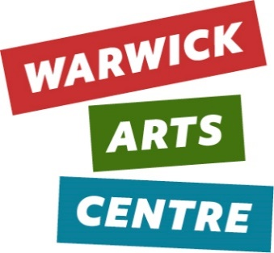
WAC Student Collab Events [Breaking Eggs]
INFORMATION PACK
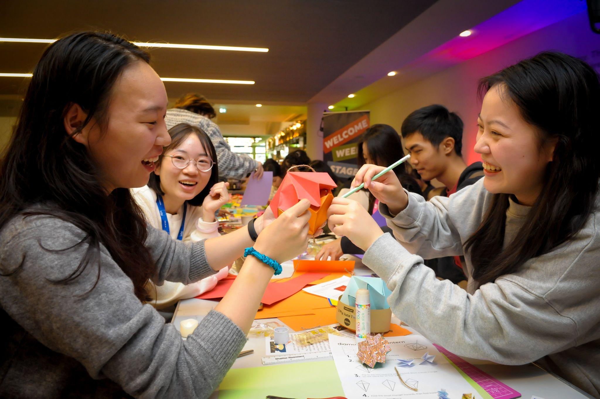
Thank you for your interest in running a student-led event at Warwick Arts Centre. Being at the centre of a University Campus, it is a core aim to support the next generation of artists and arts audiences. We have had some incredible, exciting collaborations with students and societies in the past, and we are always keen to hear about new emerging ideas and talent.
To ensure the process is fair and open to all, we ask students to fill in a form and prepare a presentation. A panel of our staff members will then meet on a termly basis to select those events we can host and support.
We are able to support up to two student collab events a term. Unfortunately, we do have more requests than we can support, but this shouldn’t put you off! Wherever we can, we will give feedback and we support people with widely varying experience. You can also resubmit at a later date if your application has not been successful the first time round.
You can ask for forms in alternative formats, and you can ask for informal discussions with staff if you think this might be a barrier to you getting your ideas across. We’re committed to making this opportunity accessible, so please don’t be afraid to ask if you would like additional support.
We look forward to hearing your ideas!

What can we do at the Arts Centre?
The Arts Centre is a multi-artform centre. We programme live events such as theatre and dance, we programme musical events, cinema screenings, visual arts exhibitions and practical, creative workshops. We have expertise across all areas, and we may be able to support activities that fall under these categories. To give you more of an idea of the kind of events we can support. We include some case studies of past student events.
Case Studies
Black [Untitled] - Night in Harlem
Black [Untitled] is a student society focussed on promoting the work of Black artists, poets and musicians on campus. They approached us with an idea for a Night In Harlem, based on the time of the Harlem Renaissance. They saw parallels with the work of their society, the current cultural climate and the pool of African American creativity of 1920s-30s Harlem. They wanted their event to reflect this and came up with a well thought out proposal of how to achieve this.
We worked with Black [Untitled] to present a night of music and poetry in the foyer space of the Arts Centre. The society wanted to work with a band from Birmingham who specialise in working with live poetry. We were able to pay their fees as well as provide PA/backline for them. We also helped to dress the space by sourcing appropriate tables and decorations as well as providing pizza from Benugos for the audience. Finally, we were able to offer marketing advice and support through WAC’s social media networks as well as event support through the wider WAC team.
“The event was definitely a success!” - Maureen, Black [Untitled]
The Hands that Made Us Screening - Shomi, Shekemi, Suhayla and Chantel
The Hands That Made Us was a project led by four female students from Afro-Caribbean backgrounds who created a thought-provoking film that highlights the experiences and challenges faced by Black women in today's society by shining a spotlight on the women who raised them. They presented the film alongside a piece of live theatre and a panel discussion in the Helen Martin Studio.
The group presented Warwick Arts Centre with a well-made pitch document that showed clearly how they planned to create the film and the live event and really took care to show how they would safeguard the people involved. The event was made possible with funding, this enabled the group to hire a screen and projector, purchase catering from Rootes, print the magazine that accompanied the live event and pay for technical support for the evening.
“Your dedication, expertise, and commitment significantly impacted our event. I honestly can't thank you enough for your invaluable contributions as well as giving us the opportunity to hold it in WAC.” - Shekemi Osunbunmi

Denzel Kira & John Bernard - Generation App
John Bernard is an established poet, spoken word artist, and youth mentor from Stoke Aldermoor in Coventry. He approached us to put on a show with his mentee, a talented 17-year-old poet, Denzel Kira.
Both John and Denzel have experienced the effects of growing up in areas affected by stark poverty and gang-related violence. Denzel, although still in school has grown up around these issues and has once been a victim of a gang-related stabbing attack.
John and Denzel were keen to celebrate the talent and creativity amongst Coventry’s young people whilst also confronting some of the harmful effects of living in areas where so-called ‘postcode wars’ regularly affect day to day life. Moreover, they wanted to demonstrate how social media plays a part in this, meaning that children as young as 10-11 are groomed into gang lifestyle patterns by what is shared with them via their social media feed.
Their piece, Generation App was a sell-out show and a thought-provoking, memorable evening for our audiences. We have subsequently hosted the premiere of Denzel Kira’s film, Tracy which explores similar themes and sold out in just one day, due to the incredible network of support Denzel has attracted through his art.
“We poured our hearts into this project and the incredible response left us speechless. Grateful for all the support.” John Bernard
What Can’t We do?
We can’t collaborate on work that doesn’t relate to the Arts Centre’s vision. Any collabs must be creative or open up our programming.
So, this could be a workshop or a performance. But it could also be a series of talks about the sculpture trail, or meditation in the gallery, inspired by the artwork.
Unfortunately, we receive more requests than we can support, so we need to prioritise those events that support the Arts Centre’s vision. We have reduced rate hire options for students who would like to use the Arts Centre for their own activities. If you would like to find out more, please email artscentrehires@warwick.ac.uk
We can’t support student exhibitions in the Mead gallery, and we have very limited capacity for student cinema screenings in screen 3, but we will try to accommodate or suggest an alternative venue if needed.
To justify the support, time and resources that come along with supporting a big public event free of charge, we need to make sure your work will benefit our communities too. Please have a read of the vision below – you’ll see it’s a broad set of principles and will allow for lots of different ideas and activities.
Find Common Ground
We’re on a mission to make sure the extraordinary mix of arts we share is matched by the extraordinary mix of people who share it with us.
We love to see events that bring people together, that platform underrepresented voices or offer opportunities to talk and reflect.
Break a Few Eggs
We’re passionate about the arts because we’ve felt how powerful they are. We want to get that amazing power out there into more people’s hands and hearts.
To do that, we have to be brave. We have to be ready to do things differently. Knock down barriers, burst bubbles, question traditions, rework, reframe, reimagine, uncover, unlock, unleash. If we really care about sharing the arts with more people, we have to stand up and be counted.
We want events that push boundaries, that feel unique. Don’t be afraid to try something new or experiment. Have an idea that you’ve never seen anywhere else before? Perfect! We want events that will keep people talking after the close.
Go on Journeys
Like all the best things in life, the journey is what counts. And everyone’s journey is different. We all come to the arts and to the meanings that matter to us from different places, at different times and in different ways. We’re here to inspire you to take more trips to new places, maybe for the first time.
We know the arts we share are just the beginning. The experience you have before, during and after, the stories you tell and the memories you make are everything.
Events that might bring new people to the arts centre are key. Is your event accessible? Does it feel relatable?
Some Other Considerations
- We cannot support activities that fundraise.
- Events must be inclusive, sensitive to all cultures and beliefs.
- Think about your audience. We cannot programme material that could cause offence to families and children in publicly accessible spaces. Might you need to consider a closed door venue?
- Student collabs need to be open to the public. We cannot make events open only to select societies or groups.
- Student collabs cannot charge entry, they must be free to access
- Activity needs to fall within our usual opening hours.
- Consider safeguarding, could this event trigger someone? What things will you put in place to minimise impact?

What Can I get help with?
- We can support with marketing your event on our Arts Centre social media channels and website. You’ll need to make sure your material works within our Brand Guidelines. We can’t post images with external logos on for example.
- We can provide our spaces and some equipment, more details below. We can potentially provide some tech support, including lighting & sound for live events.
- We can offer our collective many years of expertise; we can offer additional support from and connections to other artists. We can provide lots of feedback and first-hand knowledge on producing (putting on events.)
- We may be able to provide some budget for materials
- We can provide food from our suppliers on campus.

What equipment is available?
Depending on where you would like to host your event, we can provide a PA system and lighting. We can also provide microphones, DI boxes, monitors, and a grand piano.
We can supply 6 x long trestle tables, chairs, exhibition boards.
Unfortunately, we cannot provide DJ decks, instruments (unless a piano), or backline items such as guitar/bass amps and drumkits.
If you require equipment which we cannot provide, please discuss with us as part of your application.
Where can we put on work?
Where we can programme work is defined by our other events, but broadly we can programme student collabs in:
- Gallery Foyer
- Gallery
- Studio
- HMS
- Cinema Screen 3

Budget
We have some funding we can make available to you to put on your event.
We have to use certain suppliers, and we often find that some costs are overlooked, so rather than cost it up, we just ask that you make a list of the things you think you’ll need to make your event happen, and we will talk through the costings with you as we move through the application process.

How to apply
Firstly, please email creativelearning@warwick.ac.uk to tell us in no more than two paragraphs what your idea is.
Think about:

- Why you are interested in putting on an event
- What your event idea is
- What themes you are interested in and working on
- Why the Arts Centre? Have a look at our Mission!
We are also happy to accept a video, or a voice note, no longer than 4 minutes. Please write WAC Student Collabs Expression of interest (EOI) in the subject header.
If you have any questions about the application process or any access adjustments, please contact Tara on the above email.
Form
Following your EOI, we will send over a Microsoft Form to fill in, to get a bit more info and help you think through the practicalities.
Your EOI and form will be the basis of your application.
There will be one deadline for the EOI and Form per term. Forms should be submitted in the previous term for an event the following season. For example, Spring applications will be Summer events.
Keep an eye out on the web page for details of when this is. We cannot accept late submissions, but you can submit again for the following term.
Selection Process
We will give you a Template Slide Deck to fill in with some important questions and considerations to respond to, you will have 15 minutes to present this to a panel of 3-4 people from the Arts Centre.
You may want to alter the design or order of the slides, or use a different format altogether, but we ask that you address the core questions. The whole process will take 25 minutes. If you would like any accessible adjustments around this process, please talk to us ahead of time.
We will be in touch to notify applicants of the outcome within 2 weeks of the above discussion.

Commitment to Equality, Diversity, Inclusion & Justice
“The power of the arts to delight, challenge, and inspire is the thing that will bridge gaps, heal division, and forge new connections between us.”
It’s a core part of our vision to ensure that we are open and accessible to everyone, this includes our audiences, artists and staff. We actively invite applications from those who are currently underrepresented in the arts and are happy to talk the application through with anyone who has access needs, has taken a different educational route or has identified any other barriers not here identified.
Coventry is a rich and diverse city; Warwick Arts Centre’s artists and programming should be representative of the people it serves.
The Team
Chris Mapp, Head of Music
Kate Walters, Programme Manager
Thomas Ellmer, Exhibitions Curator
Becca Randle, Audience Development Officer
Tara Johnston-Comerford, Creative Learning Coordinator

